Deep Learning based Image Segmentation & Feature Extraction

* Week 4 – Xujiong Ye

Assignment Submission

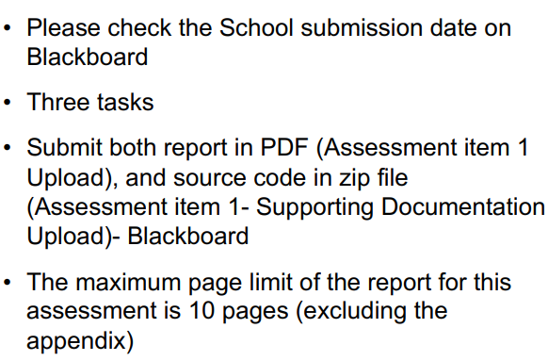

Deep Learning

Convolution Neural Networks CNNs

Main Computer Vision Tasks

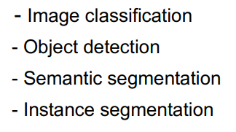

Common segmentation nets

* FCN – Fully convolutional network
* DeepLab V1, V2, V3
* U-Nets
* MASK R-CNN
* Etc